SHIVGADHI ENGLISH SCHOOL
Shivraj-1, Kapilvastu
1st Internal Evaluation - 2082
Class: Nursery Subject: Step to Hand Writing
Name: __________________________________________ Roll.No. _________
- Trace the standing lines.


- Trace the steeping lines.

- Trace the left standing lines.
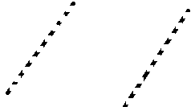

- Trace the right standing lines.
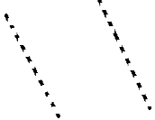

THE END
SHIVGADHI ENGLISH SCHOOL
Shivraj-1, Kapilvastu
1st Internal Evaluation - 2082
Class: Nursery Subject: Step to Hand Writing
Name: __________________________________________ Roll.No. _________
- Trace the standing lines.

- Trace the steeping lines.

- Trace the left standing lines.

- Trace the right standing lines.

THE END

